Vector class->

1.resizable Array/growable array

2.duplicates are allowed.

3.insertion order preserved.

4.null insertion possible.

5.hetrogenous objects are allowed.

6.serilizable and clonable.

7.Random Access interface.

8.Syncronised.->thread safe// diffrent from array,.

9.vector is best choice if u have retrivale operation.

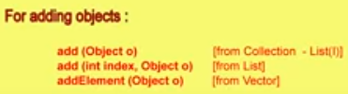

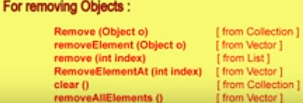

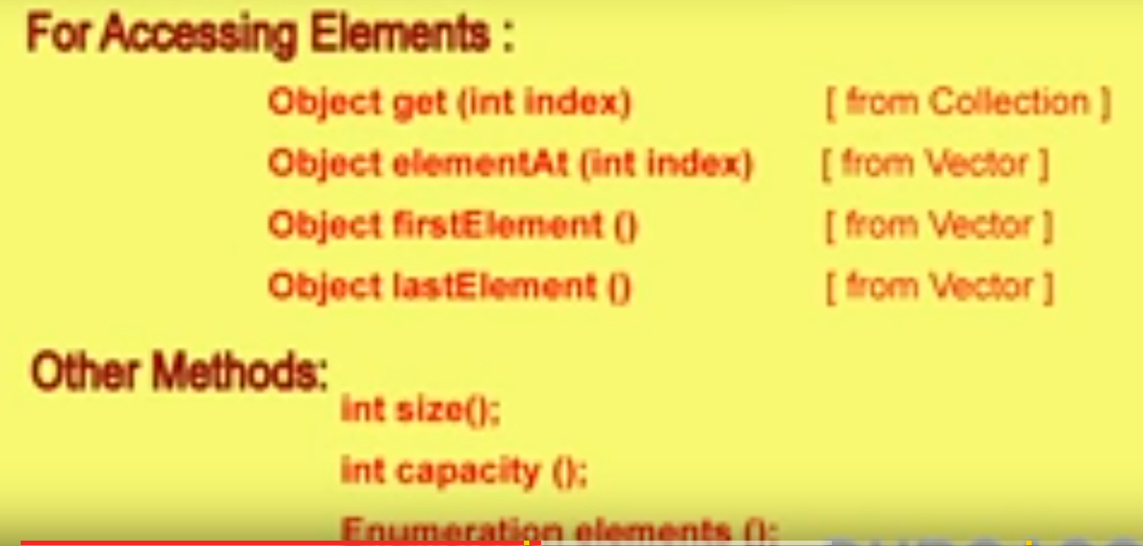

Size and capacity->capacity how many element we can add.and size is current size,

Vector class constructors->

1.Vector V=new Vector();

To create empty list ;It has 10 initial capcity;

New capacity =2*currentcapacity;

2. Vector v= new vector(int initial capacity);

Advantg->performance ;

3. Vector v=new Vecotr(int initial ,int increment);

For not to get more space;

1000->1005; to 2000 hojyega agr 5 increment use na kre to;

Vector V=new Vector(1000,5);

4.Vector v =new Vector(collection c);

*/**  
 * Created by Rishabh on 4/15/2017.  
 */*import java.util.*;  
  
public class Vect {  
  
  
 public static void main(String ...args)  
 {  
  
Vector v =new Vector();  
System.*out*.println(v.capacity());  
for(int i=1;i<=10;i++)  
{  
 System.*out*.println(i);  
  
}  
  
System.*out*.println(v.capacity());  
v.addElement(**"A"**);  
System.*out*.println(v.capacity());  
System.*out*.println(v);  
  
 }  
  
}

